**EXPERIMENT REPRODUCTION OF MUON AND DATA ANALYSIS**

Ziao LIU

*Department of Physics, Hong Kong University of Science and Technology, China*

[zliuca@connect.ust.hk](mailto:zliuca@connect.ust.hk)

**ABSTRACT**

The muon decaying satisfies the time distribution as other particles. When muons decay in scintillator, photons will be emitted, after passing PMT, the detector can detect the signal of decaying. When the signals detected, the information will pass to electronics box to obtain digital data. Then the software will record the data and plot the histogram in real time, and offer the statistic data like total events, decay rate and observed life span. With exporting the data, we could compose Python to process the raw data and calculate experimental results and system errors to verify the theory about muon decaying and muon lifetime.

Keywords: muon decay, decay rate, muon detection, lifetime, data analysis

**1. INTRODUCTION**

The muon is an elementary particle similar to the electron, with an electric charge of −1e and a spin of 1/2, but with a much greater mass, 105.658MeV/c² [1]. As a type of lepton, muon does not have sub-structure, such that there is no composing particle for muon. Muon is unstable and it can decay to release photons, which are the indicators for detecting muon decaying. In history, muon was first discovered in 1937 by C.W.Anderson and S.H.Neddermeyer [2], and its lifetime was first demonstrated in 1941 by F.Rasetti [3],[4].

In the experiment, we should examine the equipment first to ensure that the condition of devices satisfies the experiment for correct results.

With the LED inside the Scintillator, we could select different pulse time interval, we could figure out the data accuracy of the detector with different decaying time. Then the software provides the decay rate, which is used to calculate the background rate related to different discriminator threshold. The discriminator is to filter the background noises and make the decay event will be recorded.

Theoretically, the mean lifetime of muon is 2.2μs, and the with the lifetime, the wavelength of muon could be calculated. By comparing the lifetime obtained in the experiment and the theoretical value, we could verify the theory. As for muon with positive charge or negative charge, different type of muon has different lifespan, i.e. positive muon has a longer negative muon. Then, with the ideal lifespan of negative muon and the observed lifespan, we could calculate the muon charge ratio.

With such data, we could calculate the experimental value of Fermi coupling constant to verify the theoretical value.

Then, we compose Python program to do statics work with the raw data obtained in experiment. By analyzing, we could extract the success decaying probability and compare the result with theory offered in lab manual.

To reproduce the previous experiment could help to build up the knowledge about muon and skill about working in lab.

**2. METHODOLOGY**

2.1 Detector Physics [5]

In this lab, we used scintillator, in which the muon gets into and decay, emitting electrons, and photomultiplier tube (PMT), in which the electron is accelerated to cause a larger light signal. The signal will be filtered by discriminator, which is voltage comparator, by outputting pulse for input signals above threshold and with the TTL signal, FPGA timer in electronics box was triggered to read. The read is digital data passed to computer.

2.2 Software

In the computer, a software called muon.exe has been installed. With the software, we can read the data obtained by electronics box and export the raw data file for further process. The software could show the real time decay events, and offer the data like decay rate, observed lifetime, total event and so on. The data could be stored in *data* type files or captured into *png* type images by scree shot plugin provided by Windows.

2.3 Noise

It is probable that other particles inject into scintillator and decay to trigger the readout of electronics box. With higher discriminator threshold, part of the noise could be filtered out. As the software provides the decay rate, we could compute the background rate under different discriminator threshold.

2.4 Programming

To process the data in this lab, a few Python packages are used like numpy, for calculating, and matplotlib, for creating plotting graph. With the packages, we could obtain the statistics value more efficiently.

**3. RESULTS**

3.1 Decaying time detecting interval: [6]

In scintillator, a LED could generate pulse signal with adjustable time interval. With adjusting the LED, we found that the PMT could deal with the muon with decaying time in approximately 20μs. The decaying time longer than 20μs could hardly be detected. The data at the edge is mixed with high rate error.

3.2 Discriminator threshold and the correlated decaying histograms: [7]

Below are three figures that shows the decaying histogram:

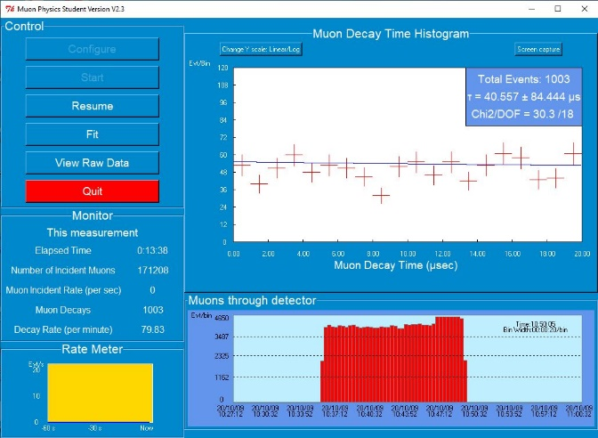Figure 1(100mV threshold)

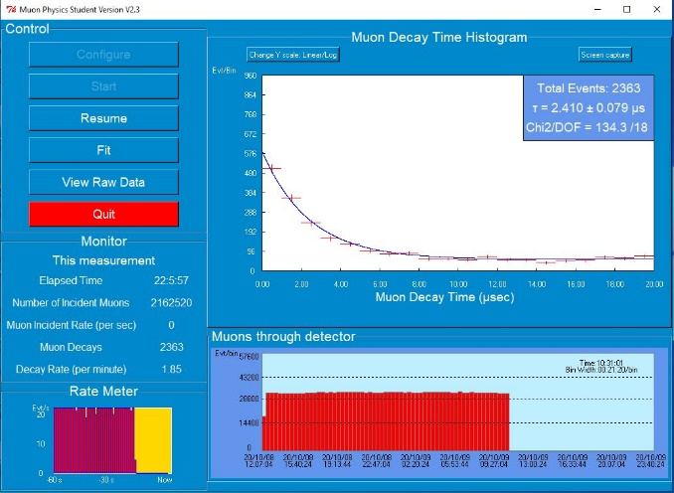Figure 2(250mV threshold)

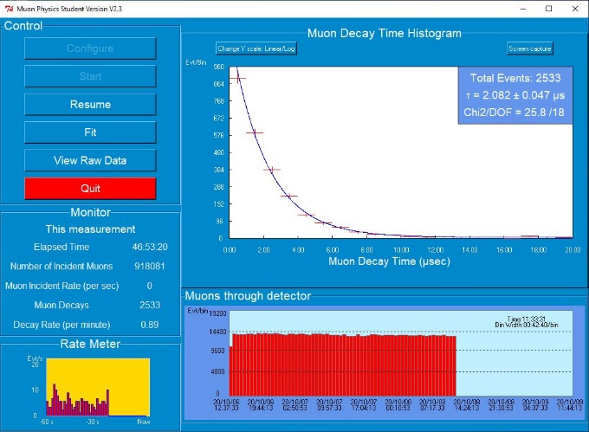Figure 3(395mV threshold)

With higher threshold, respectively our group waited for 13 minutes, 22 hours 5 minutes and 46 hours 53 minutes to obtain the histograms. Filtering the data and set 2μs as the step of time interval, and Table 1 shows the records located in correspond time intervals.

|  |  |  |  |  |  |  |  |  |  |  |
| --- | --- | --- | --- | --- | --- | --- | --- | --- | --- | --- |
| **Threshold** | **2us** | **4us** | **6us** | **8us** | **10us** | **12us** | **14us** | **16us** | **18us** | **20us** |
| 100mV | 94 | 110 | 102 | 98 | 86 | 97 | 96 | 114 | 101 | 107 |
| 250mV | 867 | 392 | 228 | 170 | 119 | 128 | 109 | 93 | 122 | 137 |
| 395mV | 1496 | 611 | 219 | 95 | 41 | 17 | 17 | 15 | 12 | 10 |

With the data, we could fit the curves into decreasing exponential functions:

for threshold = 100mV, $y=-43.40e^{-t}+101.18$, showed as Figure1

for threshold = 250mV, $y=5437.42e^{-t}+151.39$, showed as Figure2

for threshold = 395mV, $y=10771.70e^{-t}+84.70$, showed as Figure3

Simultaneously, with the decay rate, we could calculate the background rate:

When threshold is 100mV, $r=79.83$

$$R1=63.66\%$$

When threshold is 250mV, $r=1.85$

$$R2=0.03422\%$$

When threshold is 395mV, $r=0.89$

$$R3=0.007921\%$$

It is obvious that with a higher discriminator threshold, the background rate is lower and the curve is more like exponential function.

3.3 Measurement – Charge ratio and Fermi coupling constant

For the result with high accuracy, data with discriminator threshold 395mV was selected as the raw data. With:

We could obtain the charge ratio is that:

$$ρ=-\frac{τ_{-}}{τ_{+}}\left(\frac{τ_{-}-τ_{obs}}{τ_{+}-τ_{obs}}\right)=31.54±12.89\%$$

Then, the experimental Fermi coupling constant is:

$$\frac{G_{F}}{{(ℏc)}^{3}}=\sqrt{\frac{192π^{3}ℏ}{τm^{5}c^{10}}}=1.194 {GeV}^{-2} Err= \frac{1.194-1.166}{1.166}*100\%=2.40\%$$

3.4 Success decaying:

From the 2533 records, 2000 are selected. With processing, the mean of p is 0.615, the mean of success decaying is 30.725 and variance is 11.8445. The results are similar to the theoretical value with small difference. The scatter grouph are showed in Figure 4.

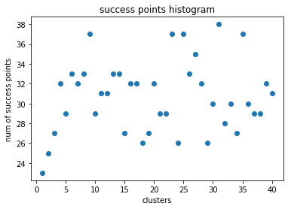 Figure 4

4. Evaluation:

As the devices are in good mode, the data are almost the same as our expectation. However, the errors still exist. For electronics box read, the minimum reading is 80ns, indicating that there might be some signals not being counted. The limitation of the read is 20μs. Hence the data near 20μs could be recorded incorrectly and the data located outside 20μs are ignored. When the discriminator’s threshold is low, many signals caused by other particles create great interference on the records. When the threshold is getting higher, the records can fit in exponential function as expectation. When doing function fitting, as the total records is around 2000, the data could also be considered as discrete and is separated into different time intervals, leading to calculation errors, which could affect curve histogram, charge ratio, success probability and so on. To extend the experiment, there could be multiple runs at same time to shorten the experiment.

5. CONCLUSION

In this experiment, together with TA and groupmates, I learnt the procedure to operate the devices like PMT and electronics box. By obtaining records from such devices, with preprocessing by special designed software, I composed Python programs to analyze data and extract the information form them. By viewing the results, I found that the observed lifetime of muon is around 2.082μs and the possibility of success decaying in expected lifetime is around 61.5%. In order to get reasonable records, the discriminator threshold should be set at high to remove the background noise. Then with good records, I get the charge ratio of muon in this experiment is 31.54%. The Fermi coupling constant is also verified.

Reference:

[1] Muon-Wikipedia <https://en.wikipedia.org/wiki/Muon>

[2] Oppenheimer, J. R., & Serber, R. (1937). Note on the nature of cosmic-ray particles. Physical Review, 51(884), 1113. doi:10.1103/PhysRev.51.1113

[3] Rasetti, F. (1941b). Evidence for the radioactivity of slow mesotrons. Physical Review, 59(706), 706-708. doi:10.1103/PhysRev.59.706

[4] Rasetti, F. (1941a). Disintegration of slow mesotrons. Physical Review, 60(198), 198-204. doi:10.1103/PhysRev.60.198

[5] T.E. Coan & J. Ye Muon Physics manual

[6] Note 3

[7] Post Lab